I am creating this document for the purpose of testing format conversions. This line is formatted as Heading 1. 1
This line is formatted as Heading 2. 1
This line is formatted as Heading 3. 1
Here is another header 1. I’ll follow it with a numbered list. 2

I am creating this document for the purpose of testing format conversions. This line is formatted as Heading 1.

Now I am adding a bulleted list, as follows:
- Here is the first bullet
- Here is the second bullet
- Here is the third bullet

This line is formatted as Heading 2.

I thought a picture (.png) would look nice right here:



And how about some yellow highlighted text?

This line is formatted as Heading 3.

However, I have nothing to say in this section. Although I think I will insert a page break.

Here is another header 1. I’ll follow it with a numbered list.

- Here is the first number
- Here is the second number
- Here is the third number

Time for another picture, this time a jpeg:

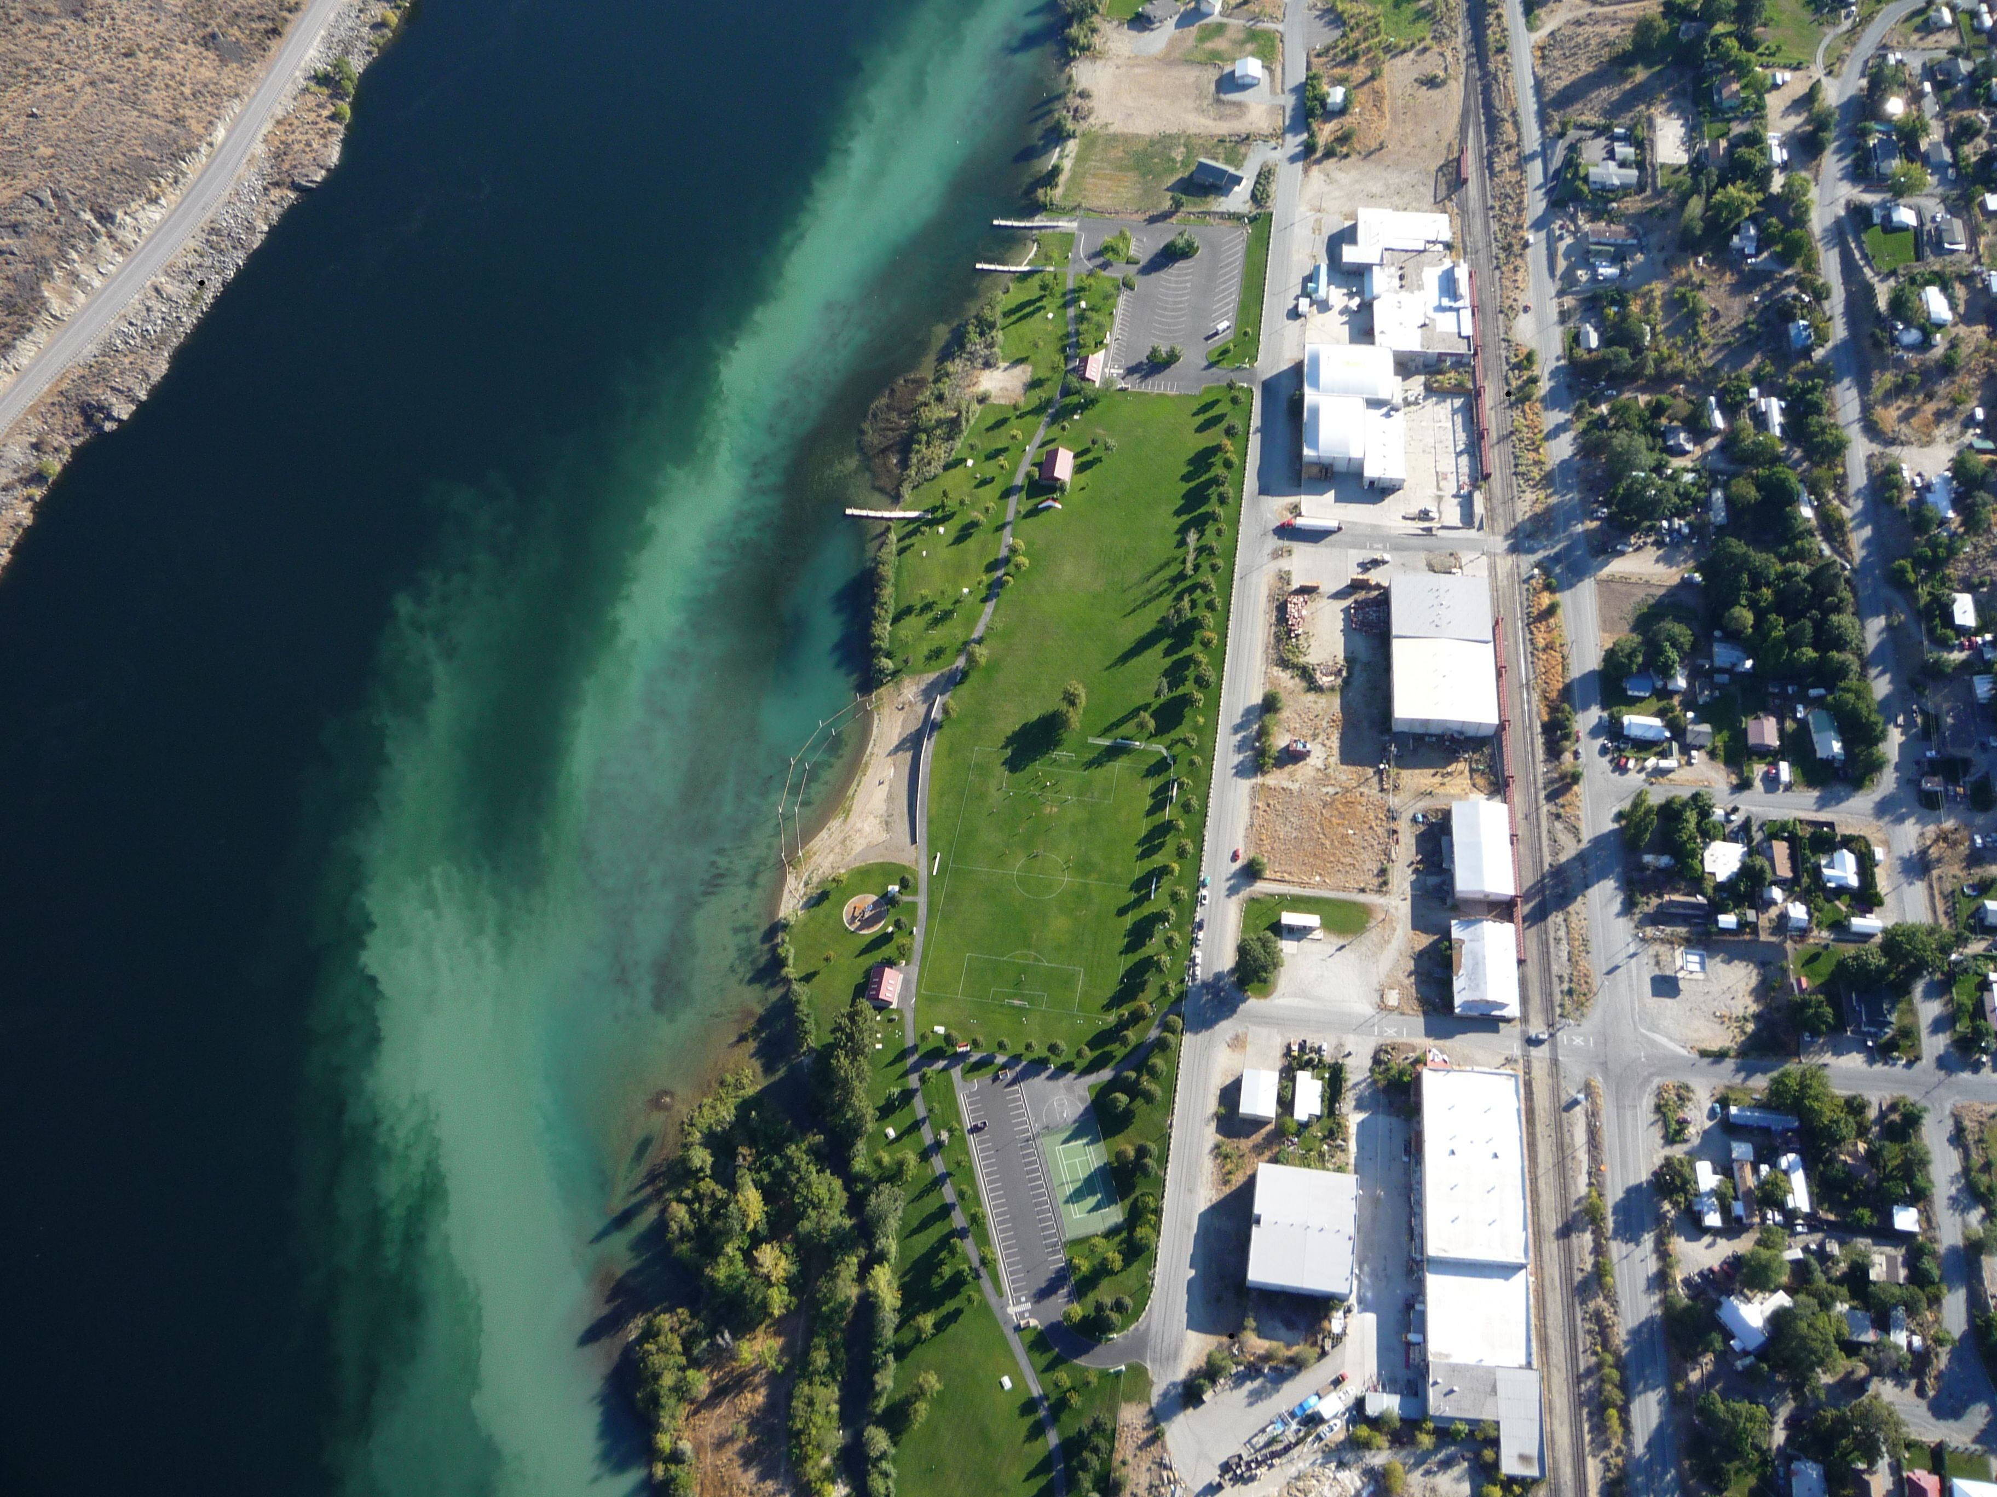
Figure 1: Coming in for landing!

Here is some text with tabs.
I’ve added a tab to the start of this sentence.
I’ve added two tabs to the start of this one.

Hey, why don’t I put in a hypertext link? Like http://www.archivematica.org?

This is a footnote.
This is another footnote.

